An Analog Circuit Platform for Simulating Typical Pulmonary Hypertensions from Point of Hemodynamics

Hong Tang*, Ziyin Dai, Miao Wang, Binbin Guo

School of Biomedical Engineering, Dalian University of Technology, Dalian city, China

Correspondence: tanghong@dlut.edu.cn; Tel.: +86-411-8470-6009Ext 3013

Academic Editor: name

Received: date; Accepted: date; Published: date

**Abstract:** Pulmonary hypertension (PH) behaves unusual hemodynamic states characterized by abnormal high blood pressure in pulmonary artery. This study sets up an analog circuit platform of human circulation system to simulate hemodynamic abnormalities of PH caused by different etiologies and pathogenesis. Four typical causes are considered. They are distal pulmonary artery stenosis (DPAS), left ventricular diastolic dysfunction (LVDD), ventricular septal defect (VSD), and mitral stenosis (MS). The authors propose a simulation method and regulation rules for chambers, vessel to adapt the abnormal hemodynamic conditions for each cause. The occurrence and development progress of each PH are simulated over time in the platform. The blood pressure, blood flow, pressure-volume relationship for chambers, vessels are numerically calculated in each PH progress. It is shown that the simulation results for the PHs are close to clinical investigations. The performances prove that the platform is qualified and effective for computer simulation of PHs. It could be a quite powerful tool to understand the hemodynamic mechanism of PH caused by various etiologies and pathogenesis.

**Keywords:** Pulmonary hypertension, Human circulation system, Distal pulmonary artery stenosis, Left Ventricular Diastolic dysfunction, Ventricular Septal Defect, Mitral Stenosis, Hemodynamic modelling

1. Introduction

Pulmonary Hypertension (PH) is a general term to describe groups of clinical syndromes characterized by high pressure in the lungs caused by different etiologies and pathogenesis. The World Health Organization (WHO) defines five groups of PH based on different causes. They are referred to as PH WHO groups [1]. The first group is pulmonary arterial hypertension (PAH), which is caused as the arteries in the lungs become narrowed, thickened or stiff. The second group is pulmonary hypertension due to left heart disease. In this group, there are problems in the manner how the heart squeezes or relaxes, or problems with the valves on the left side of the heart. The third group is pulmonary hypertension due to lung disease. The fourth group is pulmonary hypertension due to chronic blood clots in the lungs. And the fifth group is pulmonary hypertension due to unknown causes. PH lacks distinctive clinical manifestations in the early stage. No matter which group one patient is in, PH is a serious disease. If PH is not treated timely, it could progress to right heart failure and even death [2]. Since any group of PH can be reflected by the abnormal hemodynamics in the right heart and lungs, it is necessary to detect the hemodynamic changes therein. At present, right heart catheterization that directly measure blood pressure in the right heart and lung is the ‘gold standard’ operation for diagnosis and assessment of PH [3].

Computer simulation is possibly a cheap and convenient way to understand the causes and development of abnormal hemodynamics in systemic and pulmonary circulation system. Various models have been proposed for circulation hemodynamic simulation. A circuit model was built for heart failure, which found a decrease in left ventricular blood pressure, cardiac output, and a significant change in the pressure-volume (P-V) loop of left ventricle (LV) [4-6]. Korurek et al modeled severe aortic valve stenosis by increasing the value of the resistance of the aortic valve in the analog circuit model [7]. A remarkable increase in LV systolic blood pressure and aortic pressure gradient, and decrease in aortic systolic blood pressure were consequently observed. In addition, mitral stenosis [8], mitral regurgitation and aortic regurgitation [9], caused the abnormal hemodynamics in the cardiovascular system, were also studied by computer model. In [10], two causes that lead to left ventricular diastolic dysfunction were discussed. Impaired left ventricular active relaxation (IR-type) was modeled by changing the activation function of LV. Increased passive stiffness (R-type) was modeled by increasing diastolic stiffness of LV wall and septum. The simulation results showed that abnormal LV diastolic performance alone can result in decreased LV and RV systolic performance [10]. Besides, Korurek et al [11] simulated Eisenmenger syndrome with ventricular septal defect. It was found that there was a remarkable increase in the pulmonary artery pressure, but decrease in right ventricle pressure, left ventricle pressure, aortic pressure, aortic flow and pulmonary compliance.

In this study, the authors set up an analog circuit as a platform for simulating four typical PHs, including PH caused by distal pulmonary artery stenosis (DPAS), left ventricular diastolic dysfunction (LVDD), ventricular septal defect (VSD) and mitral stenosis (MS). The simulations show the occurrence and development of the typical PHs. These simulations are helpful for physicians to understand the causes to lead PHs. They have potential applications in early detection of typical PHs by screening abnormal hemodynamics in human circulation system.

2. An Analog Circuit platform for Normal Human Circulation System

Previous studies have clearly disclosed that there are general equivalence between blood flow in circulation system and current flow in analog circuit [12-14]. The blood pressure and blood flow are equivalent to voltage and charge flow. The resistance of blood flow is equivalent to electronic resistance. The inertia of blood flow can be modeled by inductance. Inflow and outflow blood to vessel are similar to charging and discharging to linear or nonlinear capacitance. Blood pumping of a heart chamber can be simulated by a nonlinear voltage source with respect to volume and time. Valves in heart and vessels are like diodes. Therefore, an improved model for human circulation system circuit was proposed in this paper and taken as a platform to simulate four typical pulmonary hypertensions, **see Fig. 1**. The P-V relationship of a vein or artery is generally modeled by three-element segment: resistance, capacitance and inductance. The initial values of the elements in the model are given in Appendix A.



**Figure 1.** An analog circuit platform for human circulation system. R: resistance; C: compliance; L: inductance; D: valves; LV: left ventricle; LA: left atrium; RV: right ventricle; RA: right atrium. Full name for the abbreviations used in subscripts: m-mitral valve; a-aortic valve; t-tricuspid valve; p-pulmonary valve; haa-head and arm artery; lna-left neck artery; lca-left clavicular artery; aop-aortic proximal; rula-right upper limb artery; rica-right internal carotid artery; lica-left internal carotid artery; lula-left upper limb artery; sap- systemic proximal arteries; rsv-right subclavian vein; rijv-right internal jugular vein; lijv-left internal jugular vein; lsv-left subclavian vein; sv-systemic veins; vc-vena cava; lpap-left proximal pulmonary artery; rpap-right proximal pulmonary artery; lpad-left distal pulmonary artery; rpad-right distal pulmonary artery; lpv-left pulmonary veins; rpv-right pulmonary veins; c- viscoelastic Resistance. D1, D2, D3, D4, D51, D52, D53, D54, D6, D7, D8, D9, D10, D11, and D12 are diodes for valves.

2.1 Ventricular Model

The ventricular model in this paper is based on the work of Chung et al [15]. Each ventricle is characterized as a time-varying elastic function that is controlled by end-systolic P-V relationship (ESPVR), end-diastolic P-V relationship (EDPVR) and a time-varying activation function . In addition, from a physiological point of view, great sympathetic tone increases myocardial elastance and shortens ventricular systole. Therefore, Lu et al [14] modified the ventricular activation function that used ventricular elasticity as a function of the sympathetic efferent discharge frequency, . A rising  increases maximum elastance and shortens ventricular systole. For example, the blood pressure in the left ventricle,, is a function of volume  and time ,

, (1)

, (2a)

, (2b)

where  represents ESPVR and  represents EDPVR.  is a constant volume.  is the end-systolic elastance.  is the volume intercept of EDPVR,  is the pressure intercept and  is an empirical constant.  is the activation function consisting of four Gaussian functions,

, (3)

where

, (4a)

, (4b)

 and  are the minimum values of the functions  and .  and  are scaling factors. Those parameters are shown in **Table 1**.

**Table 1.** Parameters for control of ventricle contractility.

|  |  |  |  |
| --- | --- | --- | --- |
| Ventricle Contractility | | | |
|  |  |  |  |
| 0 | 0.7 | 3 | 0.5 |

2.2 Atrial Model

The atrial model uses the same principle as the ventricular model, and the activation function  fitted by a Gaussian function,

. (5)

The parameters of the ventricular and atrial model are shown in **Table 2** and **Table** **3**. Therefore, the blood pressure of the four chambers , , ,  can be calculated with respect volume and time.

**Table 2.** Parameters of the ventricular and atrium model [13]

|  |  |  |  |  |
| --- | --- | --- | --- | --- |
| parameters | left ventricle | right ventricle | left atrium | right atrium |
| mmHg/ml | 4.3 | 0.8 | 0.3 | 0.3 |
| mmHg | 1.7 | 0.67 | 0.5 | 0.5 |
| ml | 25 | 25 | 20 | 20 |
| ml | 40 | 40 | 20 | 20 |
| ml-1 | 0.015 | 0.015 | 0.025 | 0.025 |

**Table 3.** Parameters of the activation functions [13]

|  |  |  |  |  |  |
| --- | --- | --- | --- | --- | --- |
| parameters |  |  | | | |
|  |  |  |  |  |
| (Left, Right) | 0.9 | 0.3 | 0.35 | 0.5 | 0.55 |
| (Left, Right) | 0.038 | 0.045 | 0.035 | 0.037 | 0.036 |
| (Left) | 0.145 | 0.275 | 0.33 | 0.375 | 0.4 |
| (Right) | 0.125 | 0.288 | 0.343 | 0.388 | 0.413 |

2.3 Nonlinear P-V relationships for specified vessels

The P-V curves of systemic veins, superior and inferior vena cava, and proximal arteries are non-linear, and the compliance of these vessels varies with pressure and volume. The nonlinear vascular model proposed by Lu and Clark et al [12], in which the compliances are expressed by P-V relationship and the vascular resistance of the superior and inferior vena cava and proximal arteries are nonlinear functions of blood volume.

***Systemic veins***Vessels stiffen as blood volume increases, and the P-V relationship can be modeled as,

, (6)

where  and  are the pressure and volume of systemic veins, respectively.  is a scale, and  is the maximum volume of systemic veins.

***Vena cava*** The P-V relationship of the vena cava is,

 , (7)

where  and  are the pressure and volume of vena cava.  and  are the unstressed and minimum volume, respectively. The P-V relationship for vena cava is consistent with the human venous system by adjusting the parameters of , ,  and . The resistance of the vena cava is,

, (8)

where  is a scaling factor, and  is an offset parameter,  denotes the maximum volume.

***Proximal artery***. The compliance and resistance of proximal artery are related to vasoconstriction, which is controlled by normalized sympathetic efferent frequency, . Hence, the P-V relationship for proximal artery is represented by both fully activated and passive states,

, (9a)

, (9b)

, (9c)

where  and  are the pressure of proximal arteries in the fully activated and passive pressures, respectively.  is the volume, and  is the minimum volume, ,  and  are scaling factors,  is a volume parameter and  is constant. The resistance of the proximal arteries is,

, (10)

where  is a scaling factor, and  is the maximal volume. The all parameters of model are shown in **Table 4**.

**Table 4.** Parameters for nonlinear P-V curves of systemic veins, vena cava and proximal arteries.

|  |  |  |  |
| --- | --- | --- | --- |
| Parameters | Values | Parameters | Values |
| **Systemic** |  | ml | 350 |
| mmHg | 40 | ml | 50 |
| ml | 3500 | **Proximal arteries** | |
| **Vena Cava** | | ml | 50 |
| mmHg | 0 | mmHg | 1000 |
| mmHg | -5 | mmHg | 0.03 |
| mmHg | 0.15 | mmHg/ml2 | 0.2 |
| mmHg | 0.4 | mmHg·s·ml-1 | 0.04 |
| mmHg·s·ml-1 | 0.001 | ml | 210 |
| mmHg·s·ml-1 | 0.025 | ml | 250 |
| ml | 130 | ml-1 | 0.1 |

2.4 Physiological Controls of the Model

***Heart rate control***. The heart rate is controlled by vagal and sympathetic neural activity that is described as a three-dimensional response by Sunagawa [16]. The human heart rate response is further improved by Lu and Clark [12],

, (11)

Where  are constants that shown in **Table 5**,  and are represented as normalized sympathetic and vagal frequencies, respectively.

**Table 5.** Parameters for control of heart rate.

|  |  |  |  |  |  |
| --- | --- | --- | --- | --- | --- |
| Heart Rate | | | | | |
|  |  |  |  |  |  |
| 35 | 140 | 40 | 32 | 10 | 20 |

2.5 Solution to the blood circulation model

In the model, the relationship between compliance , inductance , blood flow  and blood pressure  in the circuit system is,

, , (12)

and the blood volume at both ends of the capacitor , the **(12)** is also written as follows,

, (13a)

. (13b)

2.6 Simulated hemodynamics in normal conditions

The pressure at any node and the flow in any branch in the analog circuit model, shown in **Figure 1**, can be obtained numerically using an iteration scheme. All initial values of the volumes, flows are given in Appendix A. The simulated P-V loops of four heart chambers are shown in **Figure 2(a)-(d),** and the blood pressures, blood flows at typical systemic and pulmonary node are shown in **Figure 3(a)-(b)**. It can be seen that the analog circuit model works like a normal human circulation system. The left ventricle pumps blood into aortic artery with systolic pressure 121 mmHg, and the aortic pressure varies from 80 to 120 mmHg. The instantaneous flow at the outlet of left ventricle is seen in Fig. 3(b). The pulmonary related pressures and flows at representative nodes and branches are illustrated in Fig. 2(c), Fig. 2(d), Fig. 3(c) and Fig. 3(d). They all show that the simulated circulation system works in normal states.

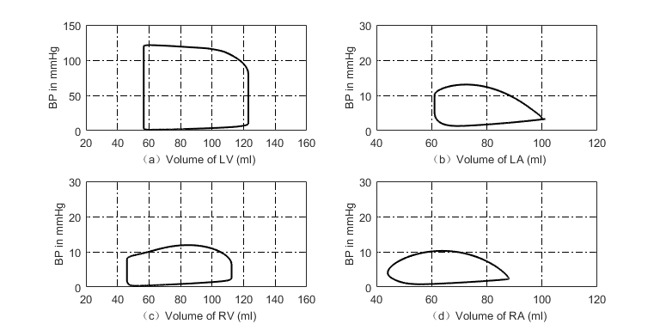

**Figure 2**. P-V loops of four heart chambers in normal state. (a) P-V loop of left ventricle; (b) P-V loop of left atrium; (c) P-V loop of right ventricle; (d) P-V loop of right atrium.

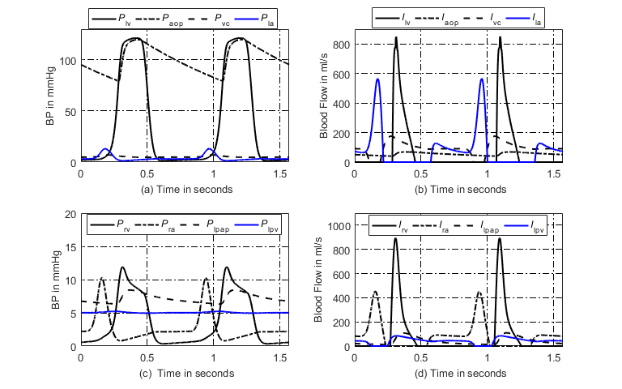

**Figure 3**. Simulated hemodynamics of two cardiac cycles. (a) Systemic blood pressures; (b) Systemic blood flows; (c) Pulmonary blood pressures; (d) Pulmonary blood flows.

3. Simulations for Typical Pulmonary Hypertensions

3.1. PAH Due to Distal Pulmonary Artery Stenosis (DPAS)

There are common pathological basis for the occurrence and development of different etiologies of PH, including vasoconstriction, pulmonary vascular remodeling and in situ thrombosis [17-18]. Pulmonary arteries are healthy and flexible, blood flows easily through the vessels. The synergistic effects of those causes an increase in pulmonary vascular resistance (PVR) and leads to PH. The increase of pulmonary artery pressure caused by pulmonary vasoconstriction is reversible in the early stage of PH. With the development of the disease, the intima and medial membrane thickens, resulting in thickening of the vessel wall, narrowing of the lumen, remodeling of angiogenesis, and showing irreversible changes in vascular structure. Thick and stiff artery walls limit blood flow and increase the resistance. As the artery narrows further, blood flow in restricted. Pulmonary vascular remodeling is the main pathological change of pulmonary hypertension. The change of vascular radius before and after vascular remodeling is shown in **Figure 4**.



**Figure 4**. Schematic example of normal vessels and after vascular structure changes. (a) Healthy pulmonary artery; (b) thick and stiff pulmonary artery.

1) Model of nonlinear P-V relationship for distal pulmonary arteries due to decreasing radius

Based on the well-known Poiseuilli’s law, the flow of liquid  is proportional to the pressure difference at both ends of the pipe and the fourth order of the pipe radius, and is inversely proportional to the length of the pipe, .

, (14)

where  is the radius of the pile,  is the pressure difference,  is the pipe length, and  is liquid viscosity. The blood flow resistance  is similar to the charge flow in a conductor, which is not directly measurable.  is proportional to , and inversely proportional to  are known by using Ohm’s law,

, (15)

thus the blood flow resistance, , is inversely proportional to the fourth power of 

. (16)

Assume  and  are constants. In order to simulate the development of distal pulmonary artery narrowing, the radius decreases as a function of time is

, (17)

where  is the initial radius and  is used for change rate. This study simulates the stenosis of the distal left and right pulmonary artery  and . The relationship between,and  are given as,

, (18a)

, (18b)

whereand are initial values of  and  which are given in **Table 6**.

**Table 6.** Initial values of pulmonary vascular resistance in the pulmonary circulation.

|  |  |  |  |
| --- | --- | --- | --- |
| Parameter | Value | Parameter | Value |
|  | 0.02 mmHg·s·ml-1 |  | 0.02 mmHg·s·ml-1 |
|  | 0.02 mmHg·s·ml-1 |  | 0.03 mmHg·s·ml-1 |
|  | 0.045 mmHg·s·ml-1 |  | 0.045 mmHg·s·ml-1 |

The previous study [19] has shown that the resistance  and compliance  are inversely related. The product of  and  is called the , which has the constant time. Therefore,

. (19)

Lankhaar et al [20] proposed that patients with PH (chronic thromboembolic pulmonary hypertension, CTEPH and idiopathic pulmonary arterial hypertension, IPAH) and without PH (NONPH) had the same -time, and the  value for NONPH, CTEPH and IPAH groups are ,  and , respectively. In this paper  is set as s. Hence, the compliance of distal left and right pulmonary artery  and are

, (20a)

. (20b)

The blood pressure  in the distal left and right pulmonary arteries. Hence, the P-V relationship of the right and left distal pulmonary arteries implied by **(18a)-(18b)** and **(20a)- (20b)** wasobtained by integration as

, (21a)

. (21b)

2) Nonlinear P-V Relationship for Proximal Pulmonary Arteries

With the development of PH, the pressure in left and right proximal pulmonary arteries gradually increases to abnormal high state. The P-V relationship becomes nonlinear to match the abnormality. On the basis of works proposed by Salazar et al [21] and Hardy et al [22], within physiological limits, the blood vessel is considered as a container for blood, increasing pressure within vessel causes an increasing vessel stiffness.  tends zero as pressure  increases, and the volume approaches the maximum volume . Therefore,

, (22)

where  is constant, and  is the maximum value of the vessel volume. The pressure implied by **(21)** can be obtained by integration,

, (23)

where , and  is an arbitrary point on the P-V curve. If , therefore,

. (24)

The nonlinear P-V relationship is applied to the left and right proximal pulmonary arteries, and the expression are

, (25a)

, (25b)

where  and  are the maximum volume of left and right proximal pulmonary arteries,

 and  are constants, the values of these parameters are given in section 4.1.

3) Compensation for Right Ventricular contractibility

Right ventricular systolic function is a comprehensive reflection of right ventricular contractility, afterload and preload. With the progress of distal pulmonary artery stenosis, pulmonary vascular resistance (PVR), afterload, mean pulmonary artery pressure (mPAP) gradually increases. In this case, right ventricular hypertrophy can be formed by increasing the thickness and contractility of one ventricular wall in order to adapt to the continuous increase of mPAP. The compensation of right ventricle in this paper is achieved by increasing right ventricular end-systolic elastance, .

The previous work [23] showed  has an upward trend with the aggravation of the disease, which increased rapidly in the early stage of PH, slowly in the middle and late. The maximum ventricular elastance  is , and mPAP=1/3*sPAP+2/3*dPAP, where sPAP and dPAP are the systolic and diastolic blood pressure in the proximal pulmonary artery. In this paper,  is modeled to increase following a piecewise function over time,

, , (26a)

, . (26b)

The piecewise function has a breakpoint as the mPAP reaches 50 mmHg,  and  are parameters to control change rate. The simulation results for the occurring and development of PH caused by distal pulmonary artery stenosis are shown in section 4.1.

3.2. PH caused by Left ventricular diastolic dysfunction (LVDD)

Left ventricular diastolic dysfunction is one of most common cause to lead pulmonary hypertension. The decrease of left ventricular myocardial compliance and filling disorder result in excessive left ventricular end-diastolic pressure, increased left atrial filling pressure. Because of this dysfunction, the left heart is unable to keep up with blood returning from the lungs. Pressure in the lungs raises. Pulmonary hypertension and congestion occur consequently [24]. The previous study showed that, the contractile function of the myocardium has no change and the ESPVR is the same as a normal heart in the left ventricular diastolic dysfunction, but the P-V relationship during diastole shifts upwards as shown in **Figure 5**, meanwhile the ejection fraction (EF) is normal or slightly decreased [25].



**Figure 5**. Schematic diagram of P-V relationship for normal and left ventricular systolic dysfunction (dashed line indicates EDPVR in left systolic dysfunction).

In the left ventricular diastolic dysfunction, impaired left ventricular relaxation and increased passive stiffness is the principal functional derangement [26]. Because of increasing in left ventricular end-diastolic pressure, there is an increase in left atrial and pulmonary venous pressure, which also increase in pulmonary artery pressure. As shown in previous study [27-28], left atrial structure and function are altered by increased LA stiffening and greater LA pressure in LVDD, and left atrial remodeling occurred in patients with LV diastolic dysfunction and LA volume expressed the severity of diastolic dysfunction [29-30]. The P-V loop of LA is out of normal relation and shift to a trend characterized by two loops. This relation is greatly different to a normal Left atrium, see in **Figure 6**. In addition, the compliance of pulmonary arteries has also changed due to the accumulation of blood in the pulmonary circulation. In the early stage of this PH, there may be no significant change in pulmonary vascular resistance, however, as the disease progresses, it eventually damages the pulmonary blood vessels, resulting in an increase in pulmonary vascular resistance [31].

This PH is closely related to the right heart, and the concept of integration of right ventricle and pulmonary circulation has been proposed by researchers in the early years [32]. Under physiological conditions, the right ventricle is connected to the low-pressure, low-resistance, and high-capacity pulmonary circulation, and the right ventricle is more sensitive to increased pressure load. In the early stage of PH, the right ventricle will compensate for the increase of pulmonary artery pressure. With the development of the disease, in order to adapt to the continuous increase of afterload and maintain the ability of ejection, right ventricle compensatory hypertrophy until right heart failure finally. In previous studies, some scholars have made attempts to compensate for right ventricular [21,33]. In this paper, the compensation of right ventricle is achieved by increasing right ventricular end -systolic elastance .



**Figure 6**. Schematic diagram of P-V relationship of left atrium in PH caused by LVDD.

1) Model of EDPVR in Left Ventricular

The P-V loop is the most direct manifestation of hemodynamic abnormalities. As shown in **Figure 5**, the EDPVR shifts upwards in the LVDD [34], which is an exponential function controlled by . and . In order to simulate the pathogenesis of LVDD, it is necessary to increase the values of  and  with respect to time to rise the left ventricle diastolic pressure,

, (27)

, (28)

where  and  are coefficients,  and  are initial values of  and .

2) Model of P-V Relationship for Pulmonary Vessels

In the development of LVDD, the authors assume that the compliance of the blood vessels in the pulmonary circulation varies within a reasonable range, the P-V relationship of proximal and distal pulmonary arteries and pulmonary veins are given in **(24)**. The end-diastolic pressure is increased due to LVDD, causing obstruction of left atrial and pulmonary veins, and blood is deposited in the left atrium and the pulmonary circulatory system, which affects the changes of vessel elasticity in the pulmonary circulation. In the process of increasing blood accumulation, the parameters  for right and left proximal pulmonary arteries, right and left distal pulmonary arteries, right and left pulmonary vein increase over time and vary within a reasonable range, which are given as,

, (29a)

, (29b)

, (29c)

, (29d)

, (29e)

, (29f)

where ,  and  are coefficients to control change rate, , , ,   and  are constants, and the P-V relationship for Pulmonary Vessels become,

, (30a)

, (30b)

, (30c)

, (30d)

, (30e)

, (30f)

where ,  , ,  and are the maximum volumes of left and right proximal pulmonary arteries, right and left distal pulmonary arteries, right and left pulmonary veins, the values of these parameters are given in section 4.2.

3) Model of Pulmonary Vascular Resistances

For pulmonary hypertension caused by LVDD, with the development of the disease, eventually irreversible damage to the pulmonary vessels results in increased PVR. However PVR increases little in the early stage of PH. Therefore, when , the resistance of blood vessels in the pulmonary circulation increase as follows,

, (31a)

, (31b)

, (31c)

, (31d)

, (31e)

, (31f)

where is the time as , and ,  and  are initial values of , ,  and , which are given in **Table 6**,  is a scale coefficient.

4) Model for Right Ventricular Compensation

With the development of this type of PH, the right ventricle in the LVDD model overcomes the increase of afterload by increasing myocardial contractility  which is given as follows,

, (32)

where  is an parameter to control change rate, .is initial value of .

5) Models for P-V Loop and Activation Function in Left Atrium

In the cardiovascular system, the left atrium acts as an elastic reservoir, passive conduit and active booster to regulate left ventricular filling. Left atrium dysfunction and remodeling are common in patients with heart failure (HF). Increasing evidence shown that Left atrium dysfunction is a positive cause of symptoms and disease progression [35]. In order to overcome the suddenly increase of left atrial pressure and volume caused by LVDD, the studies on Left atrium dysfunction found that the P-V loop of the left atrium has changed [30-31], as shown in **Figure 7**, and the systolic and diastolic blood pressures are increased to adapt to the rise of left ventricular end-diastolic pressure and pulmonary vein pressure. Therefore, the parameters of , and  in the left atrial model increase over time,

, (33)

, (34)

, (35)

where ,  and  are parameters to control change rate, ,  and  are initial values of   and .

For a normal heart, the pressure and volume of left atrium in one cardiac cycle are shown in **Figure 7(a)**. The activation function of the left atrium is well modeled by a Gaussian function is shown in **Figure 8**. During the process from normal to left ventricular diastolic dysfunction, left ventricular filling pressure continues to increase, and left atrium needs to continuously increase systolic blood pressure to return blood to the left ventricle. However, as the disease progresses, persistent long-term left ventricular end-diastolic pressure increases, causing block in blood flow back to the left ventricle. Blood silts in the left atrium, leading to an increase in left atrial volume, diastolic blood pressure. Increased pressure retrograde conduction to the pulmonary veins leads to an increase in pulmonary venous pressure, which results in an increase in pulmonary artery pressure. The pathophysiology of left ventricular diastolic dysfunction is shown in **Figure 9**. In left ventricular diastolic dysfunction, the changes of pressure and volume in the left atrium of one cardiac cycle are shown in **Figure 7(b)**. Compared with normal hemodynamic state, there are two peaks in the left atrial pressure, and the systolic and diastolic blood pressures are increased. Therefore, the authors propose a new left atrial activation function, see in **Figure 8**, and the modified activation function is expressed by the sum of nine Gaussian functions,

, (36)

As the disease progresses, the first peak amplitude has no change, but the peak becomes wide. The left atrial pressure increases during diastole, thus

, (37a)

, (37b)

, (37c)

, (37d)

, (37e)

, (37f)

, (37g)

, (37h)

, (37i)

where , , , , , , ,  and  are coefficients. The simulation results for the occurring and development of PH caused by left ventricular diastolic dysfunction are shown in section 4.2.



**Figure 7**. Schematic relationship between blood pressure and volume for left atrium. (a) for normal hemodynamics, (b) for abnormal hemodynamics due to LVDD.

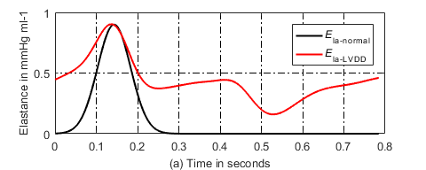

**Figure 8**. Schematic change of left atrial activation function due to LVDD.



**Figure 9**. Pathophysiology of LVDD.

3.3. Ventricular septal defect

Congenital heart disease is one of the major causes of PH, and patients with VSD is the most common congenital cardiac disorder, characterized by an abnormal opening in the septum between the ventricles, which allows blood to shunt between the left and right ventricles [11,36-37], see in **Figure 10**. Because the blood pressure of the left ventricle is much larger than the right ventricle, most of them originally are left-to-right shunting. The left-to-right shunting of congenital ventricular septal defect leads to an increase in pulmonary blood flow and pulmonary artery pressure, which in turn affects pulmonary vascular endothelial function, resulting in increased pulmonary vascular resistance, making to left-to-right shunting originally that develops bidirectional or right-to-left shunting, or appears cyanosis [38], that is, Eisenmenger syndrome (ES). ES is the terminal stage of PH in congenital heart disease, and about 50% of patients with ventricular septal defect will eventually develop into ES.

PH caused by ventricular septal defect also affects the function of right ventricle. The right ventricle needs to overcome the continuous increase of pulmonary artery pressure. As time goes on, the right ventricle will eventually decompensate, leading to right heart failure. In addition, previous studies showed that in the early stage of PH caused by ventricular septal defect, pulmonary vascular resistance can be normal, only the pulmonary artery pressure increase. However, with the development of the disease, pulmonary vascular resistance will still increase, causing pulmonary vascular lesions to an irreversible stage [39-40].



**Figure 10**. Schematic example of changes in blood flow direction for normal heart and VSD. (a) Blood flow in normal heart; (b) Blood flow in VSD.

1) Model of shunting resistance

VSD is characterized by an abnormal opening in the septum between the ventricles. The authors model the open shunting as a branch using a resistor  and a diode  in the analog circuit, see **Figure 11**. As the degree of ventricular septal defect increases, the defect area  also increases gradually, meanwhile  decreases. According to Poiseuilli’s law and **(19)**, the blood flow resistance, , is inverse proportional to four-order of radius

. (38)

 is radius of ventricular septal defect. Assuming that the ventricular septal defect is a regular circle, thus . Thus the blood flow resistance  is inversely proportional to the square of the defect area ,

. (39)

In normal heart, there is no blood flow through the septal.  is equivalent to an infinite resistance. In modelling VSD,  continues to decrease. In this paper, the defect area  is assumed to change over time,

. (40)

where  is the initial value of , and  is a coefficient. Clinical investigation released that the maximum defect area is possibly greater than 2 square centimeters.



**Figure 11**. Analog circuit model for PH caused by VSD.

2) Model of Pulmonary Vascular Resistance

Long-term left-to-right shunting VSD leads to increased blood flow in the pulmonary circulation, and abnormal pulmonary vascular endothelial function, resulting in increased PVR. In the early stage of PH, pulmonary vascular resistance is normal. With the development of the disease, the resistance of vessels is increased over time when . Increasing trend of resistance is applied to right, left proximal pulmonary arteries, right and left distal pulmonary arteries, right and left pulmonary vein.

, (41a)

, (41b)

, (41c)

, (41d)

, (41e)

. (41f)

where  is the time when , ,  and  are coefficients.

3) Model of left to Right Shunting to Bidirectional Shunting

In the VSD model, the diode  controls the direction of blood flow. As the disease progresses, a rising systolic pressure of right ventricle to overcome the afterload, and the initial left-to-right shunt thus developed into a bidirectional shunt. In this paper, when, left-to-right shunting originally that develops bidirectional shunting.

4）Model of Activation Function for Left Atrium

In the development of ventricular septal defect, part of blood in the left ventricle flows into right ventricle, directly involved in pulmonary circulation, leading to a large amount of blood entering the left atrium, resulting in abnormal enlargement of left atrial volume and increased pressure. In the normal model, the left atrial activation function does not adapt to abnormal changes in pressure and volume of left atrium. Therefore, the authors propose change the left atrial activation function, see in **Figure 12**, which is expressed by the sum of three Gaussian functions,

. (42)

As the disease progresses, the systolic and diastolic blood pressures of left atrium both increase, so there are two peaks in the left atrial activation function, and the second peak amplitude increases with time,

, (43b)

, (43c)

Where  and  are coefficients.

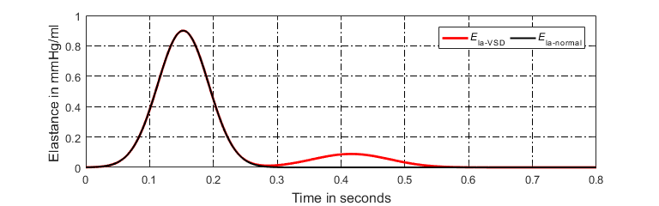

**Figure 12**. Schematic example of left atrial activation function in the VSD model.

The P-V relationship of proximal and distal pulmonary arteries and pulmonary veins are given in **(30a)**-**(30f)**, and the compensation of left atrium and right ventricle are given by the equation **(32)-(33)**. The simulation results for the occurring and development of PH caused by ventricular septal defect are shown in section 4.3.

3.4. Mitral stenosis

The mitral valve ensures the unidirectional flow of blood from left atrium to left ventricle. Pathological changes such as ischemic necrosis and trauma can cause abnormalities in the structure and function of the mitral valve, leading to mitral stenosis. Under normal conditions, blood flow from the left atrium to the left ventricle does not cause any obstacles. When the mitral stenosis occurs, the hemodynamics will obviously change [41-42]. The blood flow from the left atrium to the left ventricle encounters an obstacle, resulting in an increase in left atrial pressure, which in turn causes an increase in pressure in the pulmonary veins and pulmonary arteries, leading to PH. In addition, the right ventricle is in a long-term increase in post-load pressure, eventually resulting in right heart failure [43].

Due to limited blood flow from the left atrium to the left ventricle, the left ventricular end-diastolic volume and pressure are reduced; left ventricular end-systolic volume and stroke volume are also decreased. The P-V relationship of left ventricle in these conditions is shown in **Figure 13**.



**Figure 13**. P-V relationship of left ventricle caused by mitral stenosis.

1) Model of Mitral Resistance

In the analog circuit model, the mitral valve consists of a resistor  and a diode . From a physiological point of view, the blood flow resistance of mitral valve increases gradually from opening to closing. Increasing degree of mitral stenosis also contributes to the continuous increasing in . The increasing resistance  over time is modeled as,

, (44)

where  is initial value of , =0.015 mmHg·s·ml-1. And  is an parameter to control change rate.

2) Model of Pulmonary Vascular Resistance

In the early stage of PH caused by MS, pulmonary vascular resistance is normal. When , pulmonary vascular resistance begin to increase. The increasing resistance is involved in pulmonary vessels, such as right, left proximal pulmonary arteries, right and left distal pulmonary arteries, right and left pulmonary vein

, (45a)

, (45b)

, (45c)

, (45d)

, (45e)

. (45f)

where  is a coefficient to adjust change rate.

3) Left Atrium Compensation for Contractibility

Mitral stenosis is one of the left ventricular valve diseases. Pathological mechanisms may lead to elevated pressure in the left atrium. Therefore, the left atrium increase contractibility to overcome elevated pressure through its own regulation,

, (46)

, (47)

. (48)

where ,  and  are coefficients, ,  and  are initial values of , , and.

4）Model of Activation Function for Left Atrium

The pathophysiology of this PH is shown in **Figure 14**. In the development of mitral stenosis, the resistance of the left atrial blood flowing to the left ventricle gradually increases. Blood stasis in the left atrium results in an increase in the volume and pressure in the left atrium. The increased pressure reverses to the pulmonary veins, leading to an increase in pulmonary venous pressure, which in turn leads to an increase in pulmonary artery pressure. According to previous studies, P-V loop in left atrium has changed in the progress of PH [44]. Therefore, the authors propose change in the left atrial activation function, see in **Figure 15**, and the modified activation function is expressed by the sum of three Gaussian functions,

, (49)

where  is a coefficient. As the disease progresses, the first peak amplitude has no change, but the peak becomes wide. The second peak amplitude gradually increases over time, thus

, (50a)

, (50b)

, (50c)

where ,  and  are coefficients.



**Figure 14**. Pathophysiology of MS.

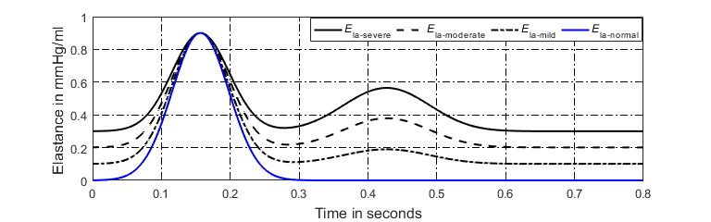

**Figure 15**. Schematic example of left atrial activation function in the MS model.

The P-V relationship of proximal and distal pulmonary arteries and pulmonary veins are given in **(30a)**-**(30f)**, and right ventricular compensation is given by the equation **(32)**. The simulation results for the occurring and development of PH caused by mitral stenosis are shown in section 4.4.

4. Simulation Results

In this paper, the simulation time is 700s, the cardiac cycle is 0.7845s (heart rate is about 76.5 beat per minute). The time step size in numerical solution is 0.0005s. The total blood volume in the circulation system is 5111.5 ml. sympathetic frequencies (,,) and vagal frequency is set as 0.5. The initial blood volume of each capacitor, current of each inductor, initial values of capacitances, inductances and resistances in the model given in Appendix A. The authors assume that the time-varying parameters is constant within a cardiac cycle and has an increment or reduction between adjacent cycles.

4.1 Simulation Results of PH caused by Distal Pulmonary Artery Stenosis

The P-V relationship of left and right proximal pulmonary arteries are given by equation **(25a)- (25b)**, and the values of , ,  and  are shown in **Table 7**. The equation **(26)** gives that  increases linearly over time. It is nature that the PH disease develops in a continuous way. Hence, it is reasonable to assume that the time-varying  keeps constant within a cardiac cycle and has an increment between cycles. The changes process in  over simulation time is shown in **Figure 16**. . The coefficients  and  are given in **Table 7**.

**Table 7.** Parameters in the simulation of DPAS.

|  |  |  |  |
| --- | --- | --- | --- |
| Parameter | Value | Parameter | Value |
|  | 20 mmHg |  | 100 ml |
|  | 20 mmHg |  | 100 ml |
|  | 0.0013 |  | 0.0008 |

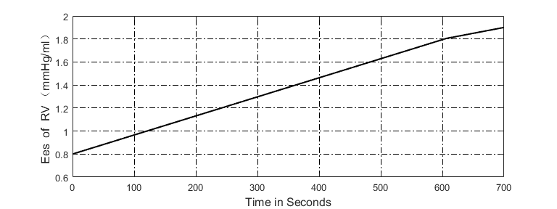

**Figure 16.** Changes in  over time.

In the simulation of DPAS, the pathological mechanism is to increase the resistance of distal pulmonary artery over time. The P-V relationship of proximal and distal pulmonary arteries are changed, and the right ventricle compensation is added to simulate a process from health to PH caused by distal pulmonary artery stenosis. The P-V relationship of four heart chambers and the blood pressure of vessels in the pulmonary circulation are shown in the in **Figure 17(a)-(d)** and **Figure 18**. Compared with the hemodynamic conditions in the normal state, in order to overcome the increase of pulmonary artery pressure, and ensure the flow of blood in the pulmonary circulation, the systolic blood pressure of right ventricle continues to increase to 80 mmHg. As shown in **Figure 18**, an increase in the resistance of the distal pulmonary artery directly leads to an increase in the blood pressure of distal pulmonary artery. The blood pressure rising in  can overcome the increase in  to make the flow of blood in the artery.

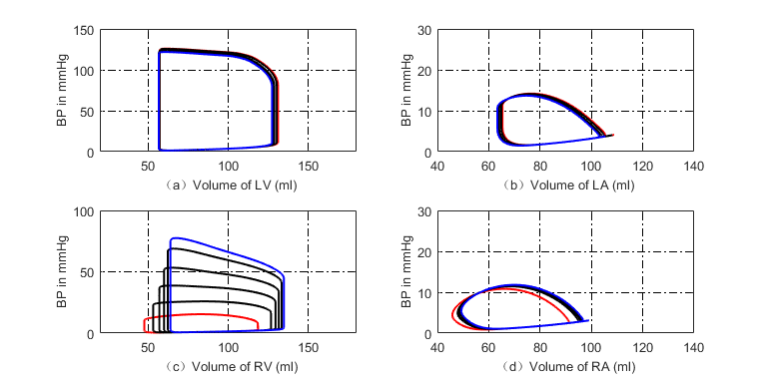

**Figure 17**. Development of P-V loops in four chambers caused by DPAS. The red loops are normal in the beginning. The black ones give the development and the blue ones show the end. (a) P-V loops of left ventricle; (b) P-V loops of left atrium; (c) P-V loops of right ventricle; (d) P-V loops of right atrium.



**Figure 18.** Development of the blood pressures in the pulmonary circulation caused by DPAS.

4.2 Simulation Results of PH caused by Left Ventricular Diastolic Dysfunction

The P-V relationship of proximal, distal pulmonary arteries and pulmonary veins are given in **(30a)-(30f)**. The values of , , , , , , , ,,,  and  are shown in **Table 8**. The value of adjustable parameters in the PH model due to LVDD are given in **Table 9**. The modified activation function of left atrium consists of nine Gaussian functions by **(36)-(37i)**, and initial value of parameters in the left atrial activation function are given in **Table 10** and **Table 11**.

**Table 8.** Values of parameters  and  in the model of LVDD.

|  |  |  |  |  |  |
| --- | --- | --- | --- | --- | --- |
| Parameter | Value | Parameter | Value | Parameter | Value |
|  | 20 mmHg |  | 20 mmHg |  | 15 mmHg |
|  | 100 ml |  | 100 ml |  | 150 ml |
|  | 15 mmHg |  | 5 mmHg |  | 5 mmHg |
|  | 150 ml |  | 180 ml |  | 180 ml |

**Table 9.** Values of adjustable parameters inthe model of LVDD.

|  |  |  |  |  |  |  |  |
| --- | --- | --- | --- | --- | --- | --- | --- |
| Parameter | Value | Parameter | Value | Parameter | Value | Paramete | Value |
|  | 0.004 |  | 0.00001 |  | 0.035 |  | 0.035 |
|  | 0.035 |  | 0.0002 |  | 0.0012 |  | 0.0004 |
|  | 0.0008 |  | 0.000002333 |  |  |  |  |

**Table 10.** Values of parameters inthe left atrial activation function.

|  |  |  |  |  |  |
| --- | --- | --- | --- | --- | --- |
| Parameter | Value | Parameter | Value | Parameter | Value |
|  | 0.0004488 |  | 0.000168 |  | 0.00039 |
|  | 0.0002 |  | 0.0002 |  | 0.000168 |
|  | 0.000291 |  | 0.00028 |  | 0.0005129 |

**Table 11.** Initial values of parameters in the left atrial activation function.

|  |  |  |  |  |  |  |  |  |  |
| --- | --- | --- | --- | --- | --- | --- | --- | --- | --- |
| Parameters |  |  |  |  |  |  |  |  |  |
|  | 0 | 0 | 0.9 | 0 | 0 | 0 | 0 | 0 | 0 |
|  | 0.1 | 0.05 | 0.038 | 0.07 | 0.1 | 0.045 | 0.04 | 0.07 | 0.1 |
|  | 0.005 | 0.08 | 0.136 | 0.25  25 | 0.3 | 0.35 | 0.42 | 0.6 | 0.78 |

In the model of LVDD, the left ventricular end-diastolic pressure is increased by linearly increasing the parameters of  and . In the model, the P-V relationship of vessels in the pulmonary circulation are changed, the PVR is also increased, and the P-V relationship and activation function of the left atrium are changed to compensate for the increased left atrial pressure and volume. The simulation results are shown in **Figure 19(a)-(d) and Figure 20**. Compared with the hemodynamic conditions in normal model, left ventricular diastolic dysfunction leads to increased left ventricular end-diastolic pressure, the left atrium needs to increase the pressure to ensure the blood returns to the left ventricle. Long-term blood return is blocked, causing blood to accumulate in the left atrium and the volume also increase. Right ventricular systolic pressure also increase to overcome the increase of pulmonary artery pressure. As shown in **Figure 20**, the blood pressure of vessels in pulmonary circulation also are increased. Compared with the simulation results of DPAS model, the pulmonary vein pressure is higher than it in the DPAS model. The reason for this phenomenon is that the left ventricular end-systolic pressure is increased due to left ventricular diastolic dysfunction. The pressure in the left atrium and the pulmonary veins rises, which in turn leads to an increase in the distal pulmonary artery blood pressure.

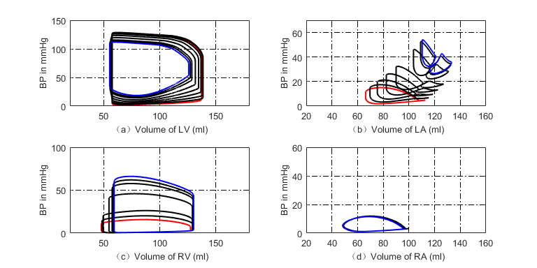

**Figure 19**. Changes of P-V loop in four chambers during normal to PH caused by LVDD, the red loop is normal, and the blue is the final simulation result. (a) Changes of P-V loop in left ventricle; (b) Changes of P-V loop in left atrium; (c) Changes of P-V loop in right ventricle; (d) Changes of P-V loop in right atrium.



**Figure 20.** Simulated the blood pressure in the pulmonary circulation of LVDD model.

4.3 Simulation of PH Due to Ventricular Septal Defect

In the simulation of PH caused by VSD, the P-V relationship of proximal and distal pulmonary arteries and pulmonary veins are given in **(30a)-(30f)**. The values of , , , , , , , ,,,  and  are shown in **Table 8**. The adjustable parameters in the model of VSD are given in **Table 12**. The modified activation function of left atrium consists of three Gaussian functions by **(42)-(43b)**, and initial value of parameters in the left atrial activation function are given in **Table 13**.

**Table 12.** Values of adjustable parameters inthe model of VSD.

|  |  |  |  |  |  |  |  |
| --- | --- | --- | --- | --- | --- | --- | --- |
| Parameter | Value | Parameter | Value | Parameter | Value | Parameter | Value |
|  | 0.00015 |  | 0.0002 |  | 0.00025 |  | 0.1 |
|  | 0.00448 |  | 0.000056 |  | 0.000056 |  |  |

**Table 13.** Initial value of parameters in the activation function of left atrium

|  |  |  |  |
| --- | --- | --- | --- |
| Parameters |  |  |  |
|  | 0.9 | 0 | 0 |
|  | 0.038 | 0.05 | 0.05 |
|  | 0.145 | 0.37 | 0.42 |

A branch consisting of a resistor  and a diode  is used to model blood flow caused by VSD. The decreasing  over cardiac beat number simulates the development of VSD. Right ventricle and left atrium increase contractibility to adapt the abnormal hemodynamics. In the simulation, the blood low is unidirectional from left to right at the beginning of VSD. However, when , the blood flow becomes bidirectional and the diode  is cancelled. By comparing the normal hemodynamic conditions, the volume and SV of left ventricle increases greatly mean while the systolic pressure decreases. The SV of right ventricle increases. However the SVs of left and right ventricles are out of balance because of the VSD branch flow. The left atrium regulates its pumping function to maintain the circulation system works. **Figure 21** gives the hemodynamics of the four heart chambers of PH caused by VSD. The corresponding blood pressures of various pulmonary vessels in the progress of PH are shown in **Figure 22**. As shown in **Figure 22(b)**, the blood flow between the left and right ventricles,  increases with time, and  also changes when bidirectional shunting. It can be observed from **Figure 22(b)** that the blood flow from left ventricle to right is large.

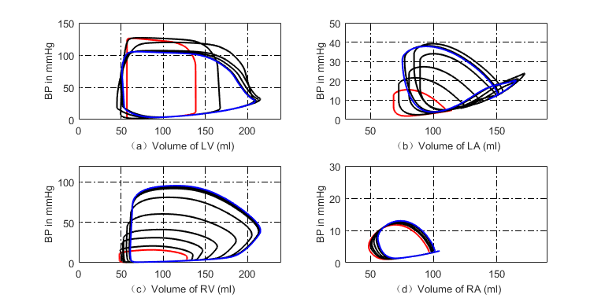

**Figure 21.** Changes of P-V loop in four chambers during normal to PH caused by VSD, the red loop is normal, and the blue is the final simulation result. (a) Changes of P-V loop in left ventricle; (b) Changes of P-V loop in left atrium; (c) Changes of P-V loop in right ventricle; (d) Changes of P-V loop in right atrium.



**Figure 22.** The blood pressures and blood flows in PH development caused by VSD. (a) The blood pressures in the pulmonary circulation; (b) The blood flows between left and right ventricles.

4.4 Simulation Results of PH caused by Mitral Stenosis

In this simulation, the P-V relationship of proximal and distal pulmonary arteries and pulmonary veins are given in **(30a)-(30f).** The values of , , , , , , , ,,,  and  are shown in **Table 8**. The values of adjustable parameters in the model of MS are given in **Table 14**. The modified activation function of left atrium consists of three Gaussian functions by **(49)-(50c)**, and initial value of parameters in the left atrial activation function are given in **Table 14** and **Table 15**.

**Table 14.** Values of the parameters inthe model of MS.

|  |  |  |  |  |  |
| --- | --- | --- | --- | --- | --- |
| Parameter | Value | Parameter | Value | Parameter | Value |
|  | 0.0003 |  | 0.00008 |  | 0.0003 |
|  | 0.001 |  | 0.0000056 |  | 0.000336 |
|  | 0.000336 |  | 0.000168 |  | 0.000168 |

**Table 15.** Initial value of parameters in the activation function of left atrium

|  |  |  |  |
| --- | --- | --- | --- |
| Parameters |  |  |  |
|  | 0.6 | 0 | 0 |
|  | 0.038 | 0.05 | 0.05 |
|  | 0.145 | 0.37 | 0.42 |

The increasing resistance  simulates the pathological mechanism of mitral stenosis. The P-V relationship of vessels in the pulmonary circulation, increasing of PVR, contractibility of the right ventricle, left atrium are all together adapt to abnormal hemodynamic flow caused by mitral stenosis. The simulation results are shown in **Figure 23(a)-(d)**. Compared to the normal hemodynamics, the left ventricular P-V loop remains almost no change, and SV decreases slightly. The left atrial systolic and diastolic pressures increase, and the P-V loop of left atrium has two loops. The pressures of key pulmonary vessels in this PH development are shown in **Figure 24**.

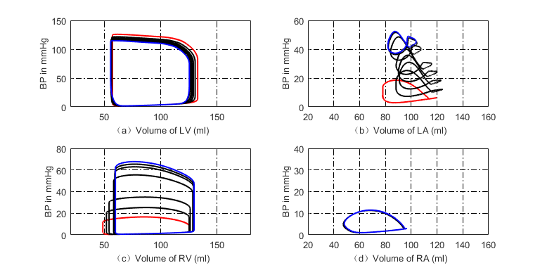

**Figure 23**. P-V loop in the four chambers during PH development caused by MS. The red loops are for the beginning of PH, and the blue ones present the end stage of this PH. (a) P-V loops for the left ventricle; (b) P-V loops for the left atrium; (c) P-V loops for the right ventricle; (d) P-V loops for the right atrium.



**Figure 24.** Development of blood pressures at key pulmonary nodes for PH due to MS

5. Discussions

Pulmonary vascular resistance is an important indicator for pulmonary hemodynamics. The irreversible injury of the blood vessels, the intima and medial thickening of the vessels leads to thickening of the blood vessel wall and narrowing of the lumen. Pulmonary vascular resistance increases, which may results in PH ultimately. It can be seen from the simulation of DPAS that the pulmonary vascular stenosis leads to increasing resistance at the distal pulmonary artery and hence results in PH. In the PHs caused by LVDD, VSD and MS, pulmonary vascular resistance may be normal in the early stage of PH, become manifest increase with elevating pulmonary artery pressure.

From a physiological point of view, the morphology and structure of right and left ventricle results adapt their functional requirements for pumping blood. The right ventricle could be considered as a sidewall that attaches additional muscles to the left ventricular wall. The wall of the right ventricle is much thinner than that of the left ventricle. Therefore, it cannot maintain normal contractile function when the mPAP increases. However, it can be well adapt to the increase of blood volume due to right ventricular reflux. When the right ventricular afterload increases rapidly, it can cause a significant expansion of the right ventricle. However, if the mPAP increase gradually over a long time, the right ventricle reform to ventricular hypertrophy by increasing the thickness of one side of the wall to meet the needed contractile force. As a result, the right ventricle can accommodate a sustained and significant increase in mPAP. A question is that the mPAP rises usually faster than the right ventricle adaptability does. The contractility does not meet the needed force. This leads obstacles in right ventricular motor function. In the simulation of the four typical pulmonary hypertensions, it is found that the P-V loop of right ventricular gradually changes from the normal to a P-V loop with very high systolic pressure, and the right ventricle volume increases with the development of the disease.

6. Conclusions

A platform consisting of analog circuit elements for simulating human circulation system is setup is this study. The developments of four typical PHs caused by different pathogenesis are simulated in the platform. On PH caused by distal pulmonary artery stenosis, the thick, stiff distal artery is modeled by increasing resistances. On PH due to left ventricular diastolic dysfunction, PH develops under the proposed model of the decrease of left ventricular myocardial compliance, filling disorder. On PH caused by ventricular septal defect, a branch is proposed to simulate the branch flow between the left and right ventricles. On PH caused by mitral stenosis, an increasing resistor is used to simulate degree of stenosis. For each PH development, regulation rules for heart chambers, arteries are proposed to adapt the hemodynamic abnormalities. The simulation results are close to clinical investigations. These works could be powerful to understand the causes that lead to PH and regulation mechanism in PH development.

Acknowledgements

This work was supported in part by the National Natural Science Foundation of China under Grant No. 61471081, No. 61601081, No. 81000643 and Fundamental Research Funds for the Central Universities under Grant No. DUT15QY60, DUT16QY13, DC201501056, DCPY2016008.

Declaration of interests

The authors declare no conflict of interests.

Supplementary materials

The matlab codes for these simulations can be accessed at **. Those who are interested reproducing the results can downloaded the codes freely.

Reference

[1] Prins KW, Thenappan T. World health organization group I pulmonary hypertension epidemiology and pathophysiology. Cardiology Clinics, 2016, 34(3): 363-374.

[2] Barnett CF, Alvarez P, Park MH. Pulmonary arterial hypertension diagnosis and treatment. Cardiology Clinics, 2016, 34(3): 375-389.

[3] D'Alto M, Dimopoulos K, Coghlan JG, et al. Right heart catheterization for the diagnosis of pulmonary hypertension controversies and practical issues. Heart Failure Clinics, 2018, 14(3): 467-477.

[4] Xiao DW, Xu BL. Hemodynamic recovery from heart failure with left ventricular assist device: a lumped-parameter simulation. Beijing Biomedical Engineering, 2016, 35(4): 367-380.

[5] Zeng Y, Gu KY, Gao M, et al. Simulation of cardiovascular system at heart failure stage. Journal of Beijing University of Technology, 2013, 39(12): 1911-1915.

[6] Liu LL, Li L, Qian KX. Modeling and simulation of a fifth-order lumped parameter cardiovascular system. Chinese Journal of Biomedical Engineering, 2012, 31(1): 13-19.

[7] Korurek M, Yildiz M, Yuksel A. Simulation of normal cardiovascular system and severe aortic valve stenosis using equivalent electronic model. Anatolian Journal of Cardiology, 2010, 10(6): 471-478.

[8] Tsalikakis DG, Fotiadis DI, Sideris D. Simulation of cardiovascular diseases using electronic circuits. Computers in Cardiology, 2003, 30: 445-448.

[9] Dolenšek J, Podnar T, Runovc F, et al. Analog simulation of aortic and of mitral regurgitation. Computers in Biology and Medicine, 2009, 39(5): 474-481.

[10] Luo C, Ramachandran D, Ware DL, et al. Modeling left ventricular diastolic dysfunction: classification and key in dicators. Theoretical Biology and Medical Modelling, 2011, 8:14.

[11] Korurek M, Yildiz M, Yuksel A, Sahin A. Simulation of Eisenmenger syndrome with ventricular septal defect using equivalent electronic system. Cardiology in the Young, 2012, 22(3): 301-306.

[12] Lu K, Clark JW, Ghorbel FH, et al. A human cardiopulmonary system model applied to the analysis of the Valsalva maneuver. American Journal of Physiology Heart and Circulatory Physiology, 2001, 281(6): H2661-H2679.

[13] Hong T, Jiao G, Yongwan P. Heart valve closure timing intervals in response to left ventricular blood pressure. Journal of Biomedical Science and Engineering, 2013, 6(1): 65-75.

[14] Olansen JB, Clark JW, Khoury D, et al. A closed-loop model of the canine cardiovascular system that includes ventricular interaction. Computers and Biomedical Research, 2000, 33(4): 260-295.

[15] Chung DC, Niranjan SC, Clark JW, et al. A dynamic model of ventricular interaction and pericardial influence. American Journal of Physiology-Herat and Circulatory Physiology, 1997, 272(6): H2942-H2962.

[16] Sunagawa K, Kawada T, Nakahara T. Dynamic nonlinear vago-sympathetic interaction in regulating heart rate. Heart and Vessels, 1998, 13(4): 157-174.

[17] Perros F, Humbert M. Physiopathology of pulmonary arterial hypertension - cellular and molecular aspects. Presse Medicale, 2005, 34(3): 232-242.

[18] Yildiz P. Molecular mechanisms of pulmonary hypertension. Clnica Chimica Acta, 2009, 403: 9-16.

[19] Lankhaar JW, Westerhof N, Faes TJ C, et al. Pulmonary vascular resistance and compliance stay inversely related during treatment of pulmonary hypertension. European Heart Journal, 2008, 29(13), 1688–1695.

[20] Lankhaar JW, Westerhof N, Faes TJC. Quantification of right ventricular afterload in patients with and without pulmonary hypertension. American Journal of Physiology-Heart and Circulatory Physiology, 2006, 291(4): H1731-H1737.

[21] Salazar E, Knowles JH. Analysis of pressure-volume characteristics of lungs. Journal of Applied Physiology, 1964, 19(1): 97-104.

[22] Hardy HH, Collins RE. On the pressure-volume relationship in circulatory elements. Medical & Biological Engineering & Computing, 1982, 20(5): 565-570.

[23] Shang XK, Xiao SN, Dong NG,et al. Assessing right ventricular function in pulmonary hypertension patients and the correlation with the New York Heart Association (NYHA) classification. Oncotarget, 2017, 8(52): 90421-90429.

[24] Komamura K. Similarities and Differences between the Pathogenesis and Pathophysiology of Diastolic and Systolic Heart Failure. Cardiology Research and Practice, 2013, 1-6.

[25] Chatterjee, K; Massie B. Systolic and diastolic heart failure: Differences and similarities. Journal of Cardiac Failure, 2007, 13(7): 569-576.

[26] Aurigemma GP, Zile MR, Gasch WH. Contractile behavior of the left ventricle in diastolic heart failure-with emphasis on regional systolic function. Circulation, 2006: 113(2): 296-304.

[27] Kurt M, Wang JW, Torre-Amione G, et al. Left atrial function in diastolic heart failure. Circulation Cardiovascular Imaging, 2009, 2(1): 10-15.

[28] Teo SG, Yang H, Chai P, Yeo TC. Impact of left ventricular diastolic dysfunction on left atrial volume and function: a volumetric analysis. European Journal of Echocardiography, 2010, 11(1): 38-43.

[29] Rossi A, Gheorghiade M, Triposkiadis F, et al. Left atrium in heart failure with preserved ejection fraction structure, function, and significance. Circulation-Heart Failure, 2014, 7(6): 1042-1049.

[30] Melenovsky, V; Hwang, SJ; Redfield, MM, et al. Left atrial remodeling and function in advanced heart failure with preserved or reduced ejection fraction. Circulation-Heart Failure, 2015, 8(2): 295-303.

[31] Raeisi-Giglou P, Lam L, Tamarappoo BK, et al. Evaluation of left ventricular diastolic function profile in patients with pulmonary hypertension due to heart failure with preserved ejection fraction. Clinical Cardiology, 2016, 40(6): 356–363.

[32] Vonk Noordegraaf A, Westerhof BE, Westerhof, N. The relationship between the right ventricle and its load in pulmonary hypertension. Journal of the American College of Cardiology, 2017, 69(2): 236–243.

[33] Acosta S, Puelz C, Riviere B, et al. Cardiovascular mechanics in the early stages of pulmonary hypertension: a computational study. Biomechanics and modeling in Mechanobio- logy, 2017, 16(6): 2093-2112.

[34] Zile MR, Baicu CF, Gaasch WH. Diastolic heart failure-abnormalities in active relaxation and passive stiffness of the left ventricle. New England Journal of Medicine, 2004, 350 (19): 1953- 1959.

[35] Donal E, Raud-Raynier P, Place CD, Gervais R, et al. Resting echocardiographic assessments of left atrial function and filling pressure interest in the understanding of exercise capacity in patients with chronic congestive heart failure. Journal of the American Society of Echocardiography, 2008; 21(6): 703–710.

[36] Perloff, JK, Rosove MH, Child JS, Wright GB. Adults with cyanotic congenital heart disease: hematologic management. annals of internal medicine, 1988, 109(5), 406-413.

[37] Ammash NM, Warnes CA. Ventricular septal defects in adults. Annals of Internal Medicine, 2001, 135: 812-824.

[38] Granton JT, Rabinovitch M. Pulmonary arterial hypertension in congenital heart disease. Cardiology Clinics, 2002, 20(3): 441–457.

[39] Daliento L, Somerville J, Presbitero P, et al. Eisenmenger syndrome factors relating to deterioration and death. European Heart Journal, 1998, 19(12): 1845–1855.

[40] Vongpatanasin W, Brickner ME, Hillis LD, Lange RA. The eisenmenger syndrome in adults. Annals of Internal Medicine, 1998, 128: 745-755.

[41] Yan T, Zhang G, Li B, et al. Pulmonary artery haemodynamic properties in patients with pulmonary hypertension secondary to rheumatic mitral stenosis. Heart, Lung and Circulation, 2012, 21(12): 782–786.

[42] Erturk M，Aksu HU, Celik O, et al. Evaluation of the effect of mitral stenosis severity on the left ventricular systolic function using isovolumic myocardial acceleration. Cardiology Journal, 2014: 21(4): 442–448.

[43] Wroblewski E, James F, Spann JF, Bove AA. Right ventricular performance in mitral stenosis. The American Journal of Cardiology, 1981: 47(1): 51–55.

[44] Stefanadis C, Dernellis J, Stratos C, et al. Effects of balloon mitral valvuloplasty on left atrial function in mitral stenosis as assessed by pressure–area relation. Journal of the American College of Cardiology, 1998, 32(1): 159–168.

APPENDIX A: PARAMETERS AND INITIAL CONDITIONS OF THE CARDIO-PULMONARY SYSTEM CIRCUIT MODEL

The values of parameters in the cardiopulmonary system circuit model are shown in **Table A1-A3**,

and the initial conditions include the blood volume at the four chambers and each vessel and the blood flow at the inductor are shown in T**able A4**.

**Table A1**. Resistors and diodes of the blood circulation model

|  |  |  |
| --- | --- | --- |
| Parameter | Description | Value |
| ***Flow Resistances*** | | |
|  | Mitral valve | 0.015 mmHg·s·ml-1 |
|  | Aortic valve | 0.02 mmHg·s·ml-1 |
|  | Head and arm artery | 13 mmHg·s·ml-1 |
|  | Left neck artery | 16 mmHg·s·ml-1 |
|  | Left clavicular artery | 16 mmHg·s·ml-1 |
|  | Proximal aorta | 1.2 mmHg·s·ml-1 |
| and | Right (Left) upper limb artery | 0.4 mmHg·s·ml-1 |
| and | Right (Left) internal carotid artery | 0.4 mmHg·s·ml-1 |
|  | Proximal arteries | See **Eq.11** |
|  | Right subclavian vein | 0.17 mmHg·s·ml-1 |
| and | Right (Left) internal jugular vein | 0.2 mmHg·s·ml-1 |
|  | Left subclavian vein | 0.2 mmHg·s·ml-1 |
|  | Systemic capillaries | 0.2 mmHg·s·ml-1 |
|  | Vena cava | See **Eq.8** |
|  | Tricuspid valve | 0.02 mmHg·s·ml-1 |
|  | Pulmonary valve | 0.02 mmHg·s·ml-1 |
| and | Right (Left) proximal pulmonary artery | 0.02 mmHg·s·ml-1 |
| and | Right (Left) distal pulmonary artery | 0.03 mmHg·s·ml-1 |
| and | Right (Left) pulmonary veins | 0.045 mmHg·s·ml-1 |
| ***Viscoelastic Resistances*** | | |
|  | Head and arm artery | 0.01 mmHg·s·ml-1 |
|  | Left neck artery | 0.01 mmHg·s·ml-1 |
|  | Left clavicular artery | 0.01 mmHg·s·ml-1 |
|  | Proximal aorta | 0.01 mmHg·s·ml-1 |
| and | Right (Left) proximal pulmonary artery | 0.005 mmHg·s·ml-1 |
| and | Right (Left) distal pulmonary artery | 0.005 mmHg·s·ml-1 |
| and | Right (Left) pulmonary veins | 0.005 mmHg·s·ml-1 |

**Table A2**. Inductors of the blood circulation model

|  |  |  |
| --- | --- | --- |
| Parameter | Description | Value |
|  | Proximal aorta | 0.001 mmHg·s2·ml-1 |
| and | Right (Left) proximal pulmonary artery | 0.001 mmHg·s2·ml-1 |

**Table A3**. Capacitors of the blood circulation model

|  |  |  |
| --- | --- | --- |
| Parameter | Description | Value |
|  | Head and arm artery | 1 ml·mmHg-1 |
|  | Left neck artery | 1 ml·mmHg-1 |
|  | Left clavicular artery | 1 ml·mmHg-1 |
|  | Proximal aorta | 0.8 ml·mmHg-1 |
|  | Right upper limb artery | 3 ml·mmHg-1 |
|  | Left upper limb artery | 2 ml·mmHg-1 |
|  | Right internal carotid artery | 2 ml·mmHg-1 |
|  | Left internal carotid artery | 4 ml·mmHg-1 |
|  | Proximal arteries | See **Eq.17** |
|  | Right subclavian vein | 10 ml·mmHg-1 |
| and | Right (Left) internal jugular vein | 10 ml·mmHg-1 |
|  | Left subclavian vein | 10 ml·mmHg-1 |
|  | Systemic capillaries | See **Eq.6** |
|  | Vena cava | See **Eq.7** |
| and | Right (Left) proximal pulmonary artery | 10 ml·mmHg-1 |
| and | Right (Left) distal pulmonary artery | 20 ml·mmHg-1 |
| and | Right (Left) pulmonary veins | 25 ml·mmHg-1 |

**Table A4**. Initial conditions of the blood circulation model

|  |  |  |  |
| --- | --- | --- | --- |
| Compartment | Value | Compartment | Value |
| Total blood volume | 4711 ml |  |  |
| ***Volume*** | | | |
| Left ventricle | 123 ml | Right ventricle | 110 ml |
| Left atrium | 63 ml | Right atrium | 53 ml |
| Head and arm artery | 111 ml | Left neck artery | 117 ml |
| Left clavicular artery | 117 ml | Proximal aorta | 64 ml |
| Right upper limb artery | 29 ml | Left upper limb artery | 19 ml |
| Right internal carotid artery | 20 ml | Left internal carotid artery | 37 ml |
| Proximal arteries | 217 ml | Systemic capillaries | 2526 ml |
| Right subclavian vein | 66 ml | Left subclavian vein | 66 ml |
| Right internal jugular vein | 69 ml | Left internal jugular vein | 66 ml |
| Vena cava | 170 ml | Right proximal pulmonary artery | 64 ml |
| Left proximal pulmonary artery | 64 ml | Right distal pulmonary artery | 140 ml |
| Left distal pulmonary artery | 140 ml | Right pulmonary veins | 130 ml |
| Left pulmonary veins | 130 ml |  |  |
| ***Flow*** | | | |
| Proximal aorta | 40 ml·s-1 | Right proximal pulmonary artery | 16 ml·s-1 |
| Left proximal pulmonary artery | 16 ml·s-1 |  |  |